

COMSATS University Islamabad, Lahore Campus
Block–C, Department of Computer Science
COMSATS University Islamabad, Lahore Campus 1.5KM Defence Road, Off Raiwind Road, Lahore

Sessional – I Examination – Semester Spring 2021
Course Title: | Operating Systems |  |  |  |  | Course Code: |  | CSC322 |  | Credit Hours: | 3(2,1)
Course Instructor/s: | Nadeem Ghafoor Chaudhry |  |  |  | Programme Name: |  |  | BS Computer Science
Semester: | 5th | Batch: | SP19-BCS | Section: | B,C |  |  | Date: | 30th March 2021
Time Allowed: | 60 Minutes |  |  |  | Maximum Marks: |  |  |  | 25
Student’s Name |  |  |  |  | Reg. No.
Important Instructions / Guidelines:
- Answer all questions.
- Do not give multiple answers for a question. Clearly cross out what you do not want me to read.
- Do not make multiple submissions.

Q1) [5+5 marks]

PID | Arrival Time | Burst Time | Priority
1 | 1 | 5 | 5
2 | 2 | 4 | 4
3 | 3 | 1 | 5
4 | 4 | 2 | 2
5 | 5 | 1 | 3
6 | 7 | 6 | 6

Use the data provided in the above table to draw Gantt Charts and calculate average turnaround time using
- Shortest Remaining Time First (SRTF)
- Priority
Keep in mind:
- Both are pre-emptive
- For SRTF if there is tie use Priority to break the tie
- For Priority scheduling if there is tie use BurstTime/RemainingTime to break the tie.
- The system is dual core, i.e two processes can execute in parallel so you will draw two Gantt Charts for each case like so

Core0
1 2 3 4 5 6 7 8 9 10 11 12
Core1
1 2 3 4 5 6 7 8 9 10 11 12

Q2) [5 marks] Why is it that a C program compiled on Linux won’t run on a Windows platform but a Java program compiled on Linux would run on a Windows platform. Draw diagram to support your answer.

Q3) [5+4+1 marks] Assume that there are no errors in the following code and program executes normally.

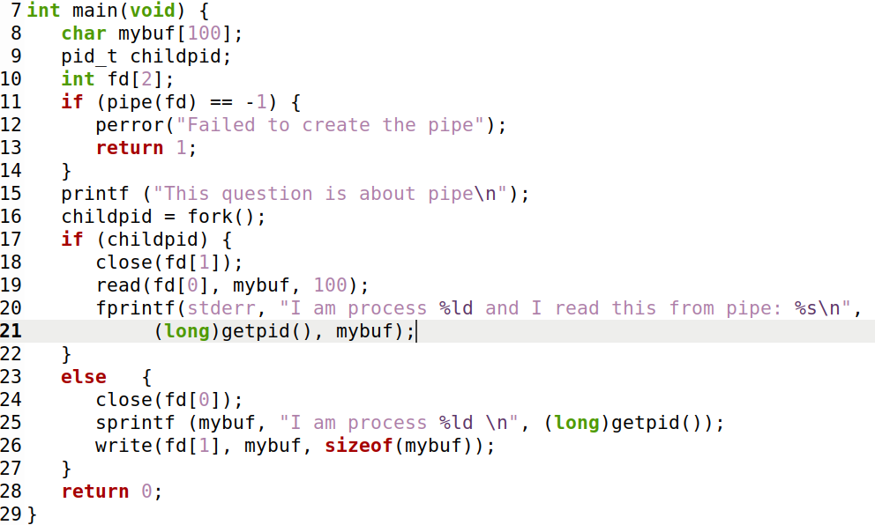

The above code is compiled into an executable called Q3.exe and when it executes its process ID is 5678 and the PID of its child is 5679.
- Write the output produced and a brief description of what the code is doing, especially lines 11 and 16 to 27.
- Make a diagram of File Descriptor Table(s) to support your answer.
- Would it make any difference to the program if lines 18 and 24 are commented out?

